For the first GET requests I first created a connection with the database in the index.js file

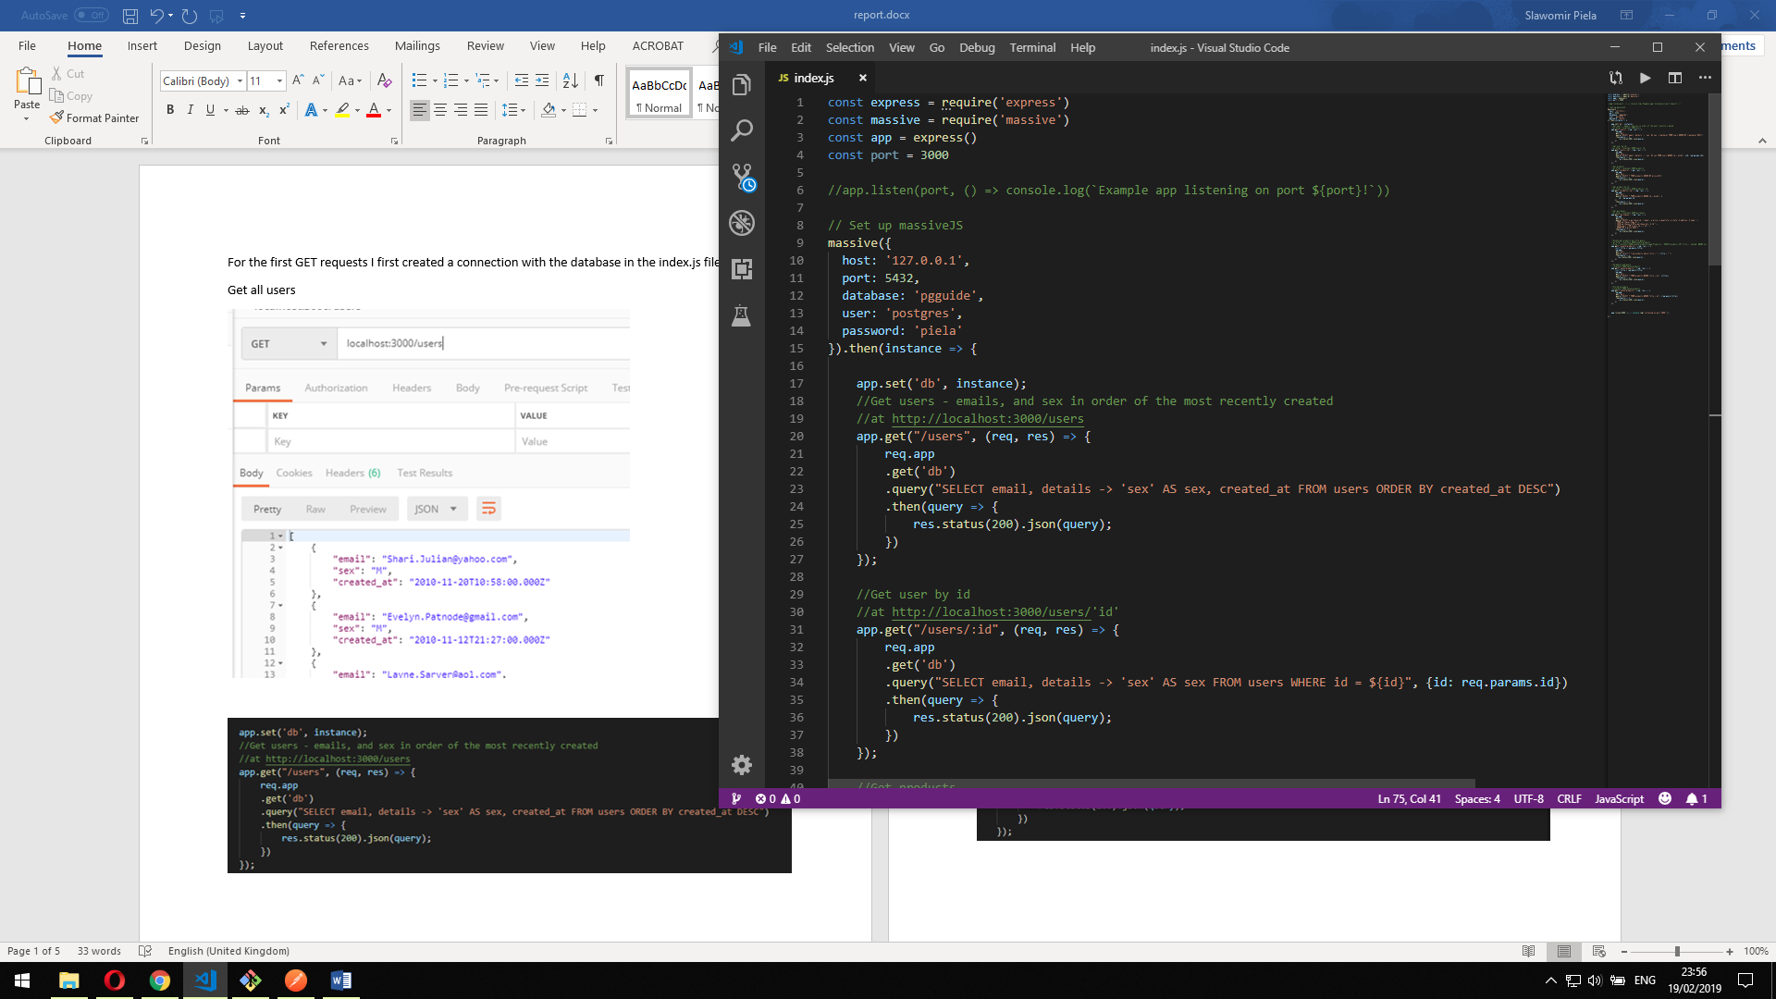

Then I procceed into working on the “instance”, calling the following queries on it:

Get all users

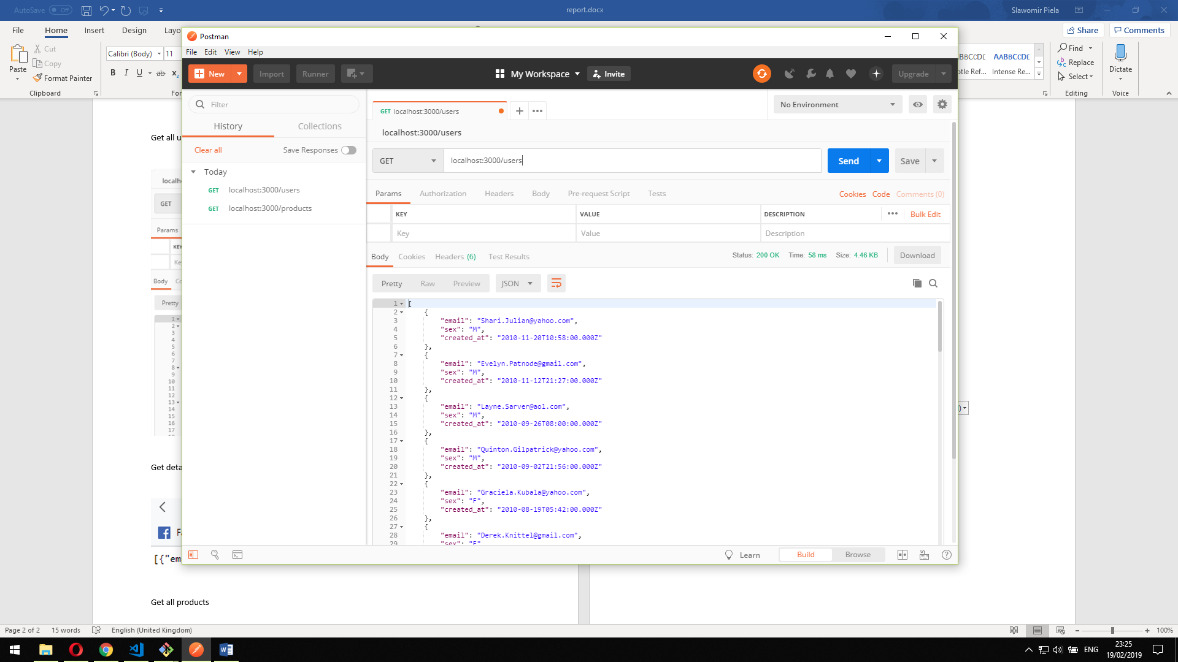

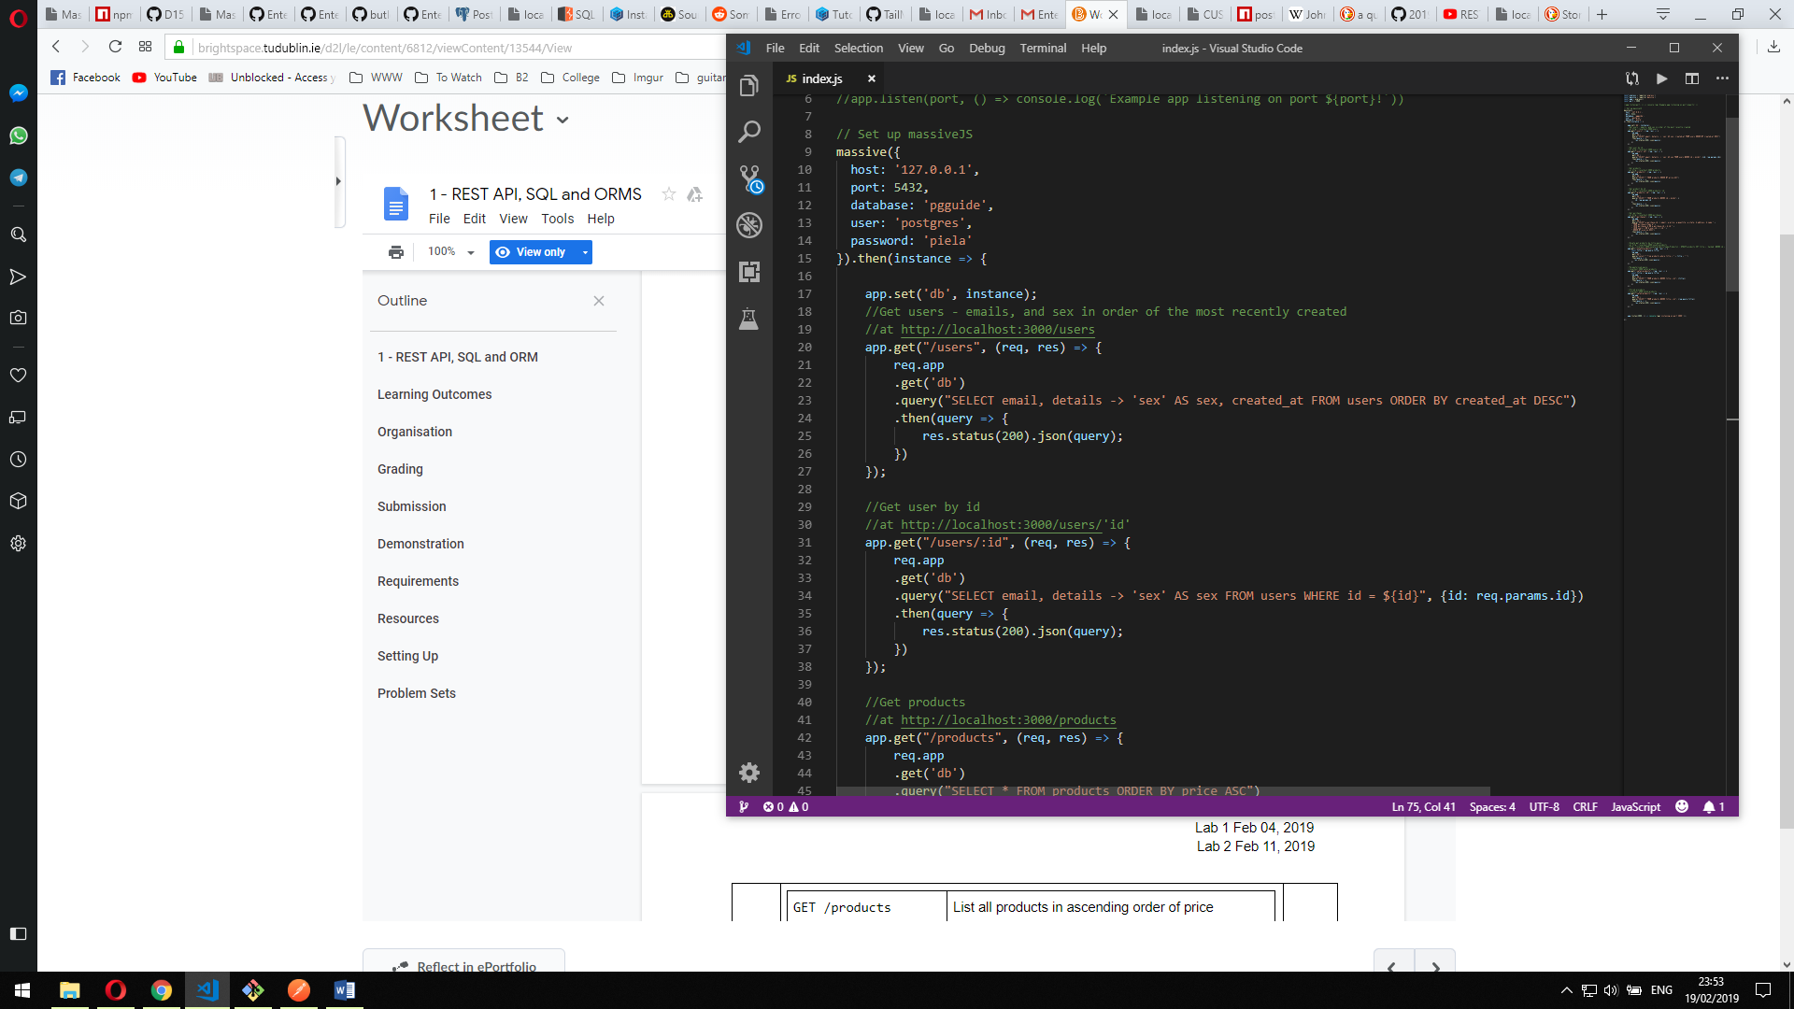

Get details of a user

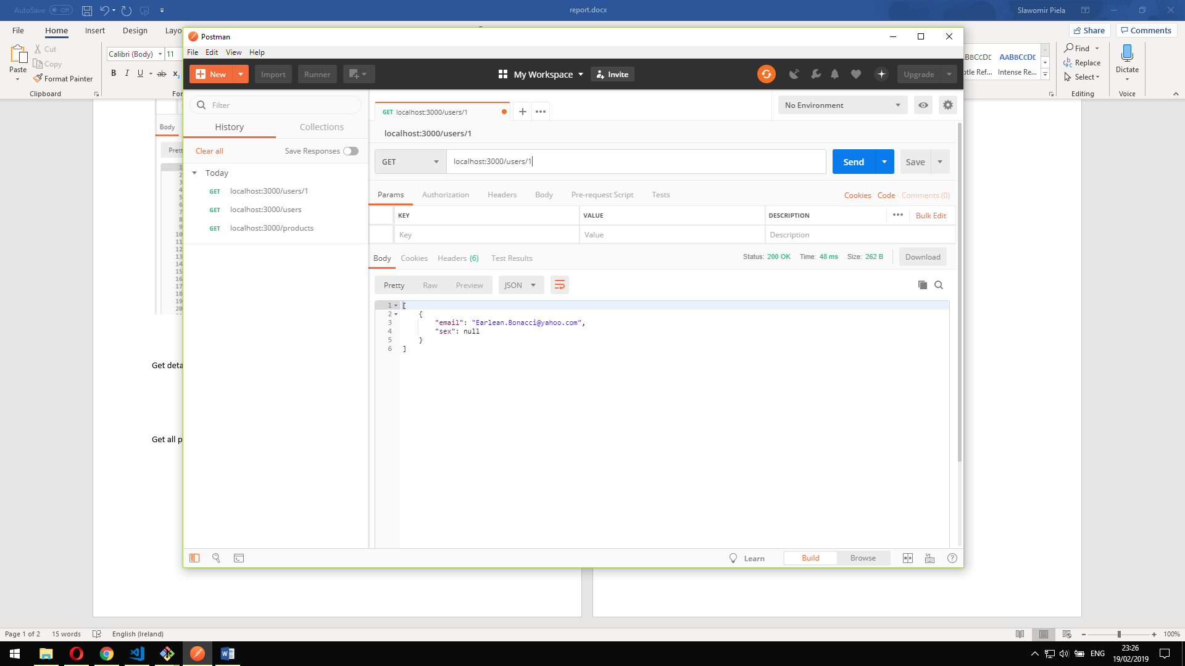



Get all products

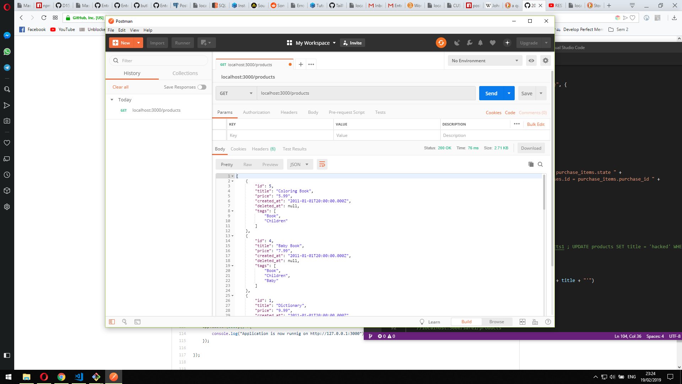

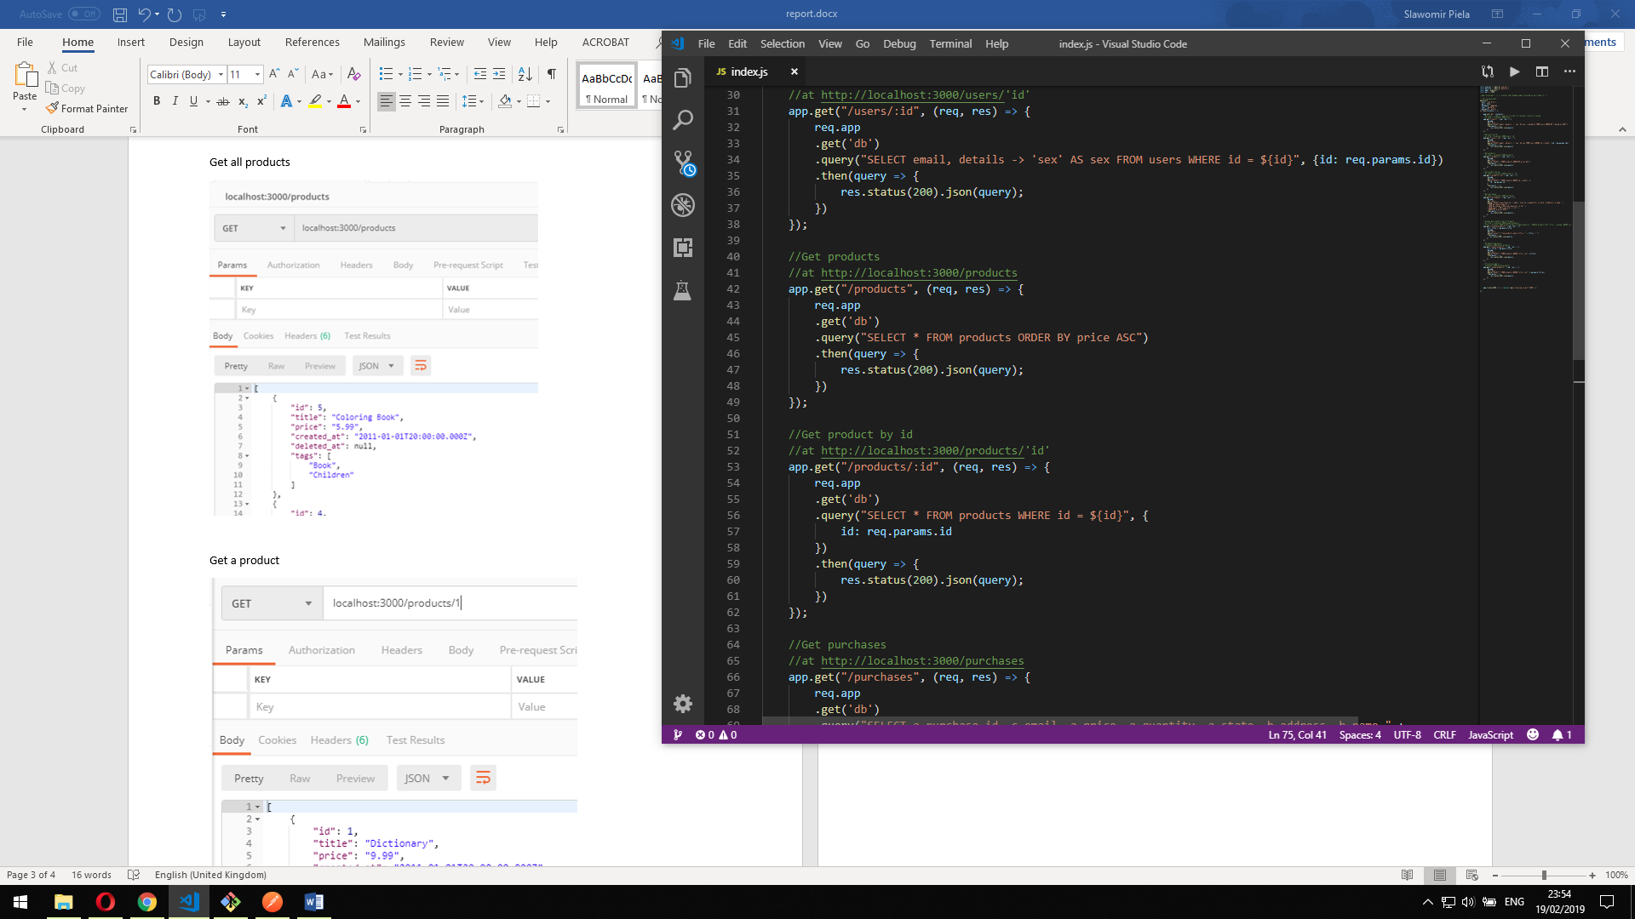

Get a product

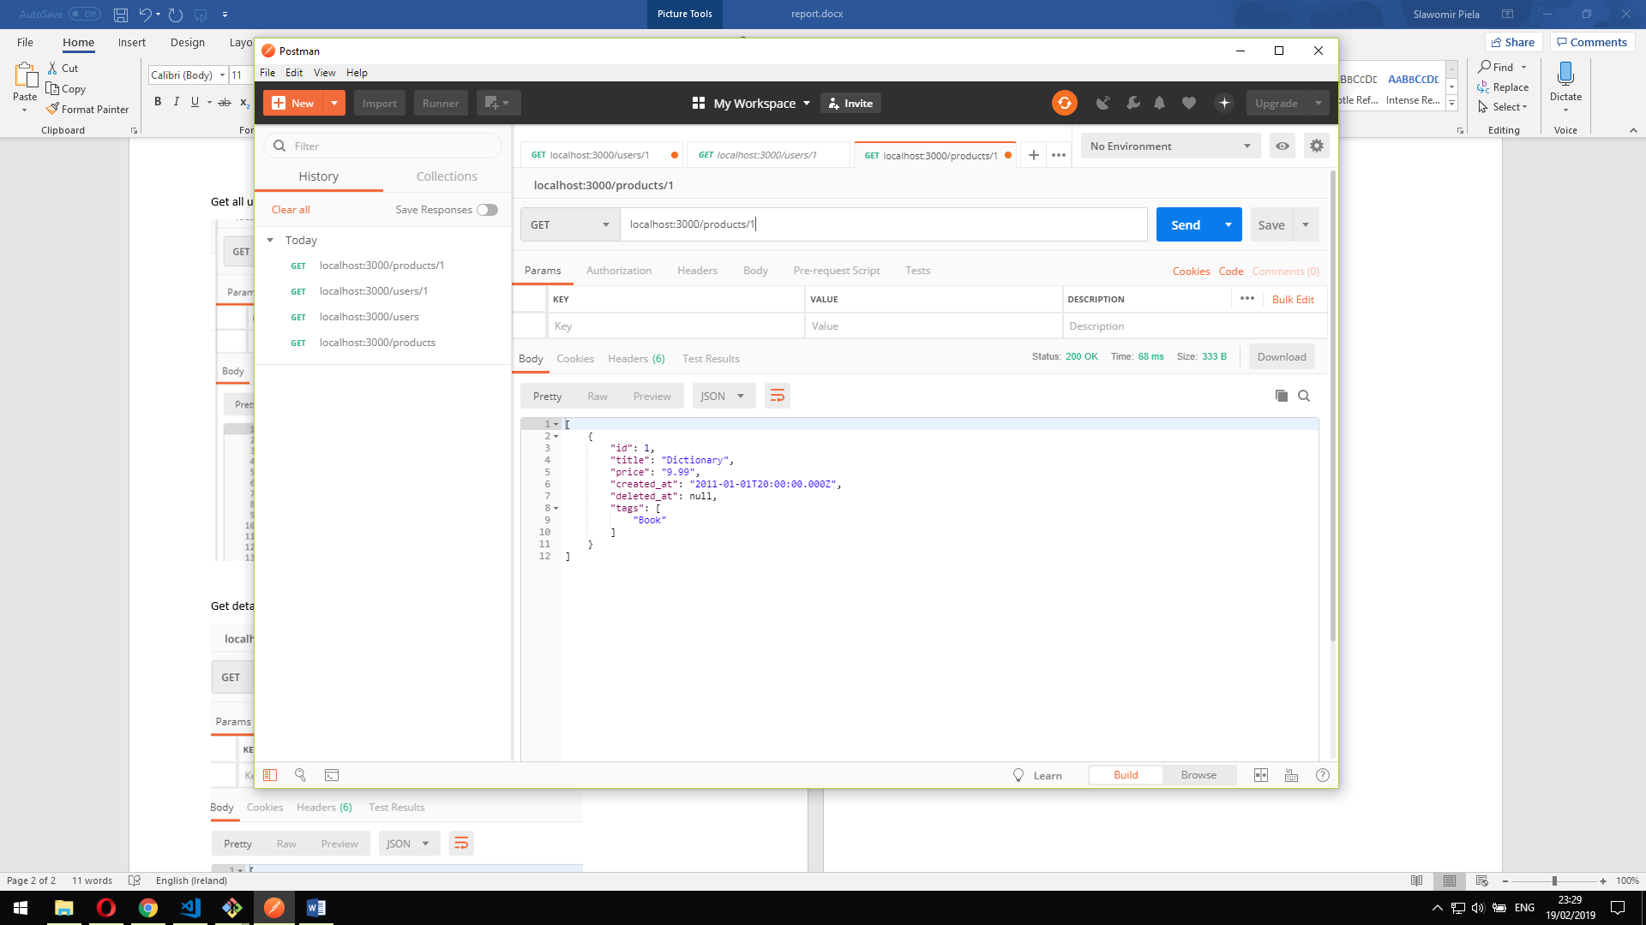



Get purchases

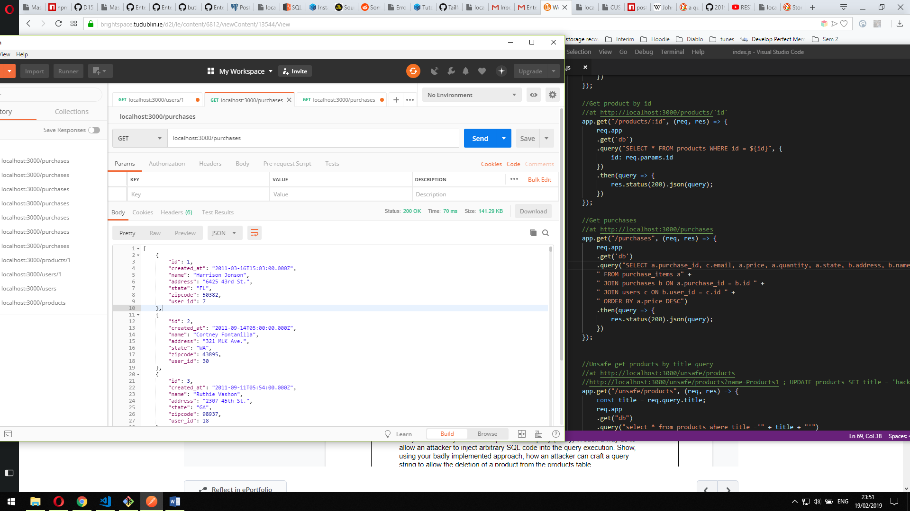

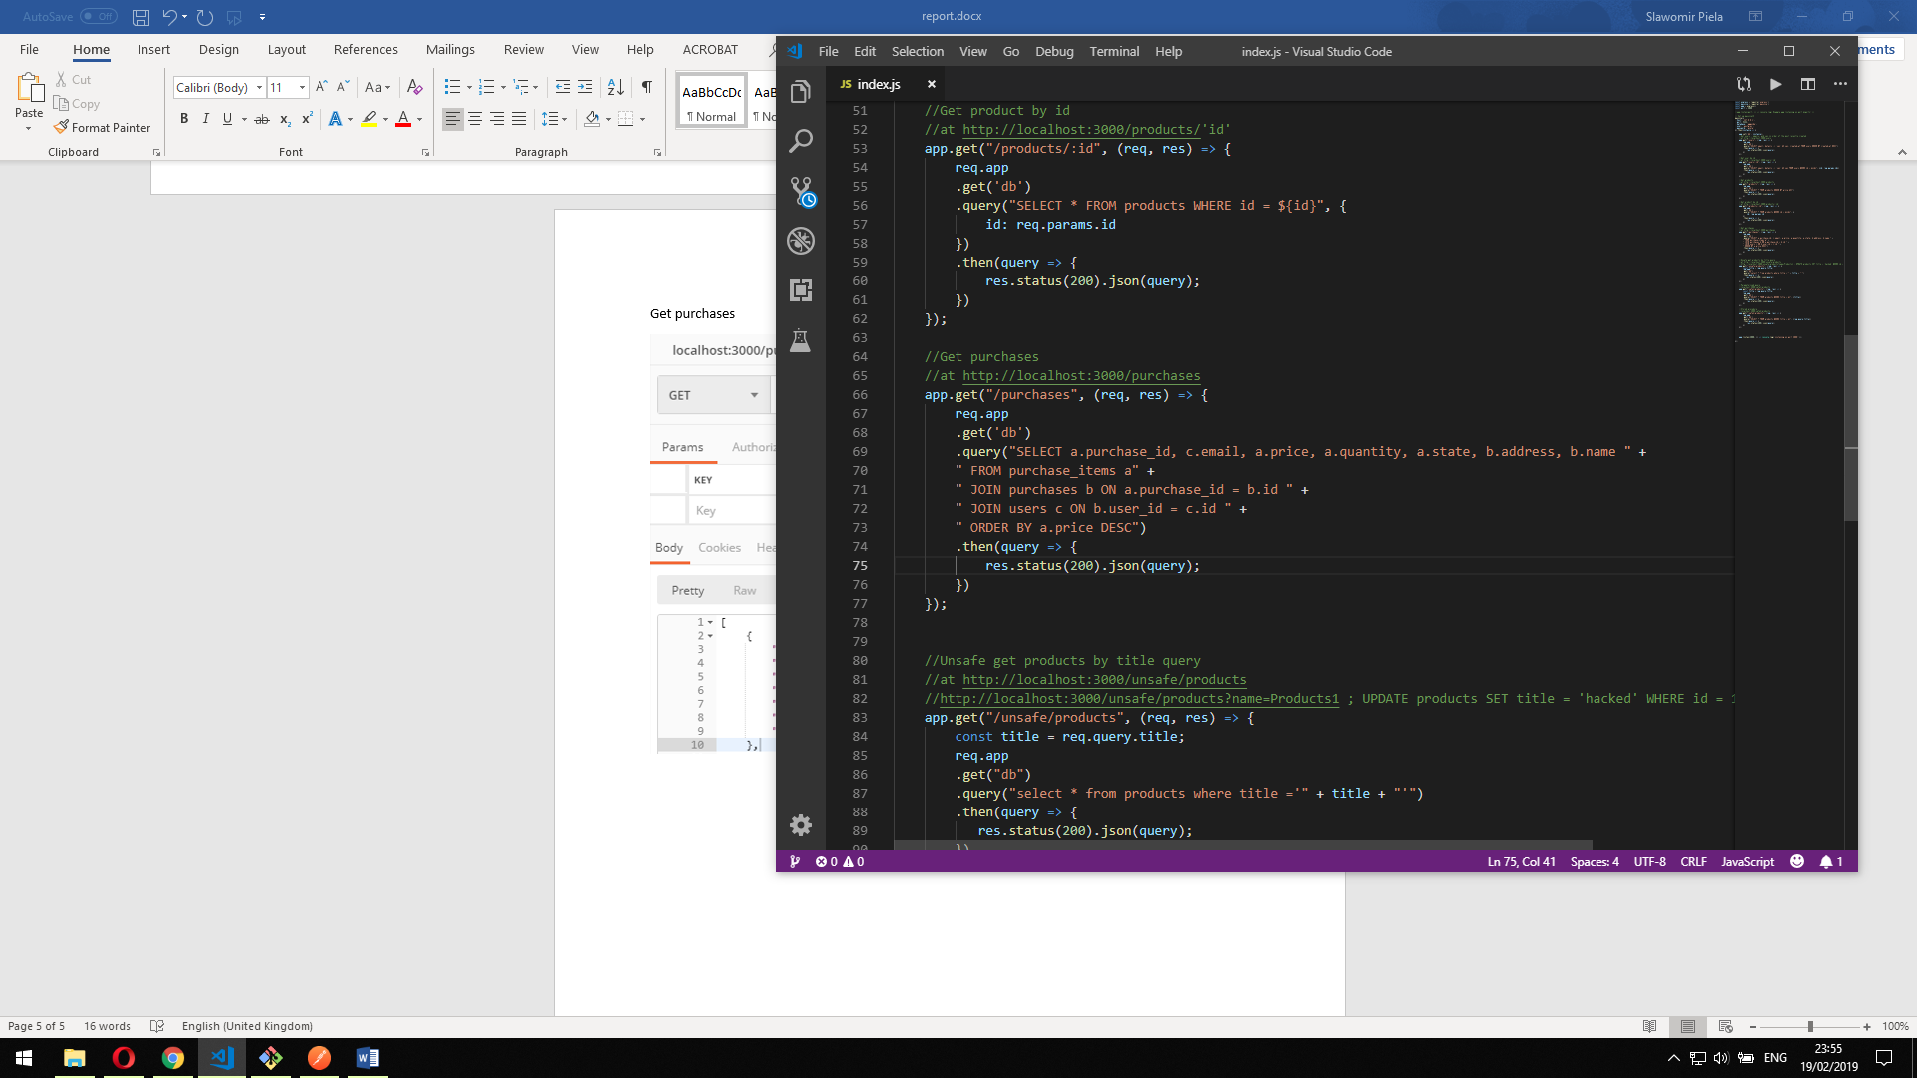

Then to create a vulnerable query I created a request in such a way that an additional query can be injected into the request such as

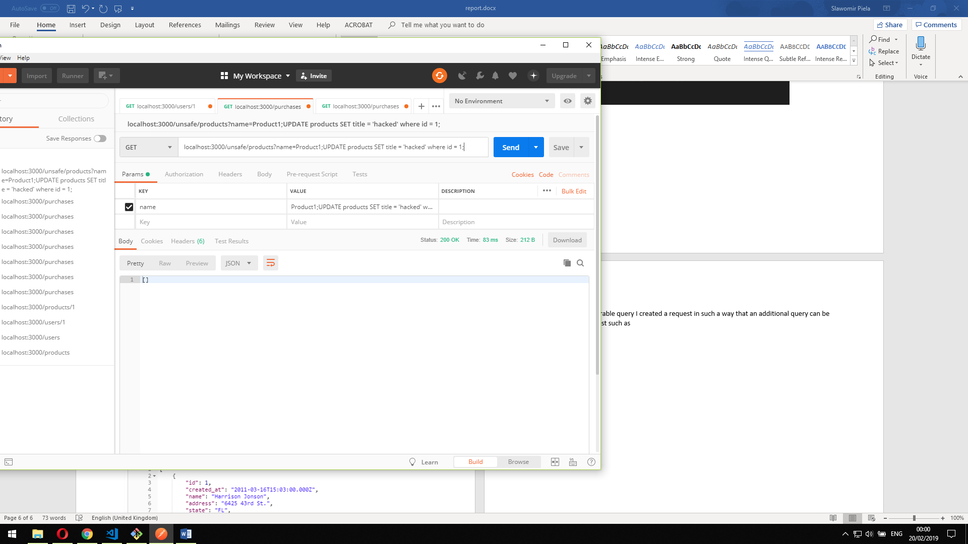

Which in this case would update product title to “hacked”

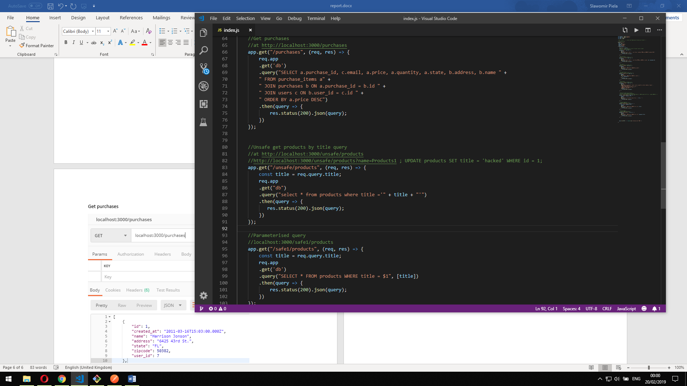

Then I fixed the vulnerability with a parameterised query:

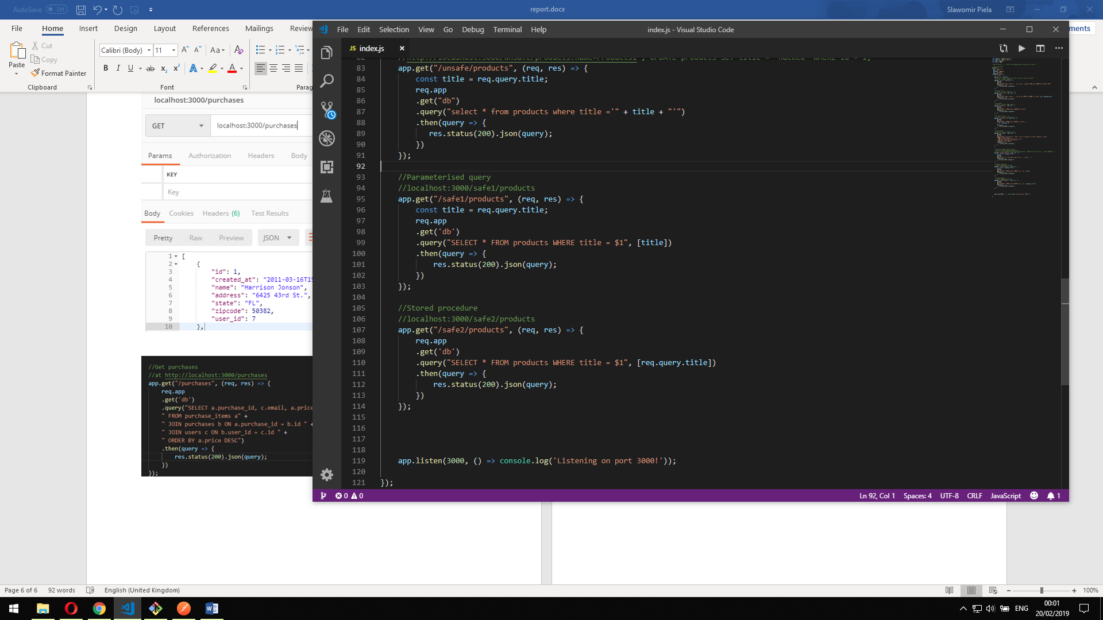

Or through a stored procedure:



Part 4 – 6

I initialized a new project “Sequelize2” to finish the 2nd part of the lab

I used “npm init -y” to create it as a new project,

Then I proceed by installing sequelize-cli with

“npm install –save sequelize-cli”

Then I initiated project with

“Node_modules/.bin/sequelize init”

This creates 3 new folders: config, models, migrations and seeders

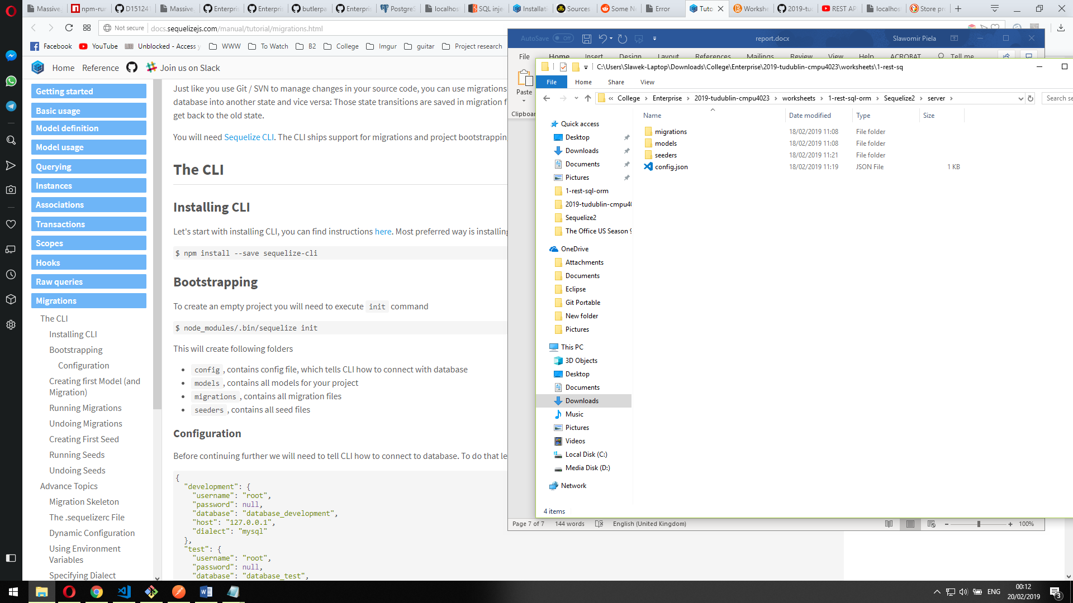

Then I opened up the config.json file to setup my db connection

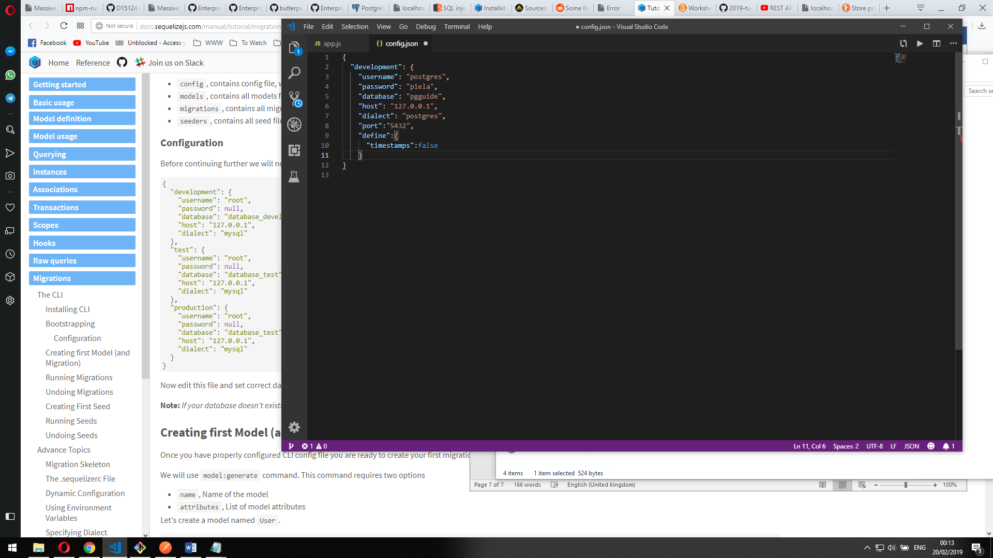

Then I had to generate models with the following commands for each table, which I then edited to add necessary associations

node_modules/.bin/sequelize model:create --name Users_Sequelize --attributes "email:string,password:string,details:string"

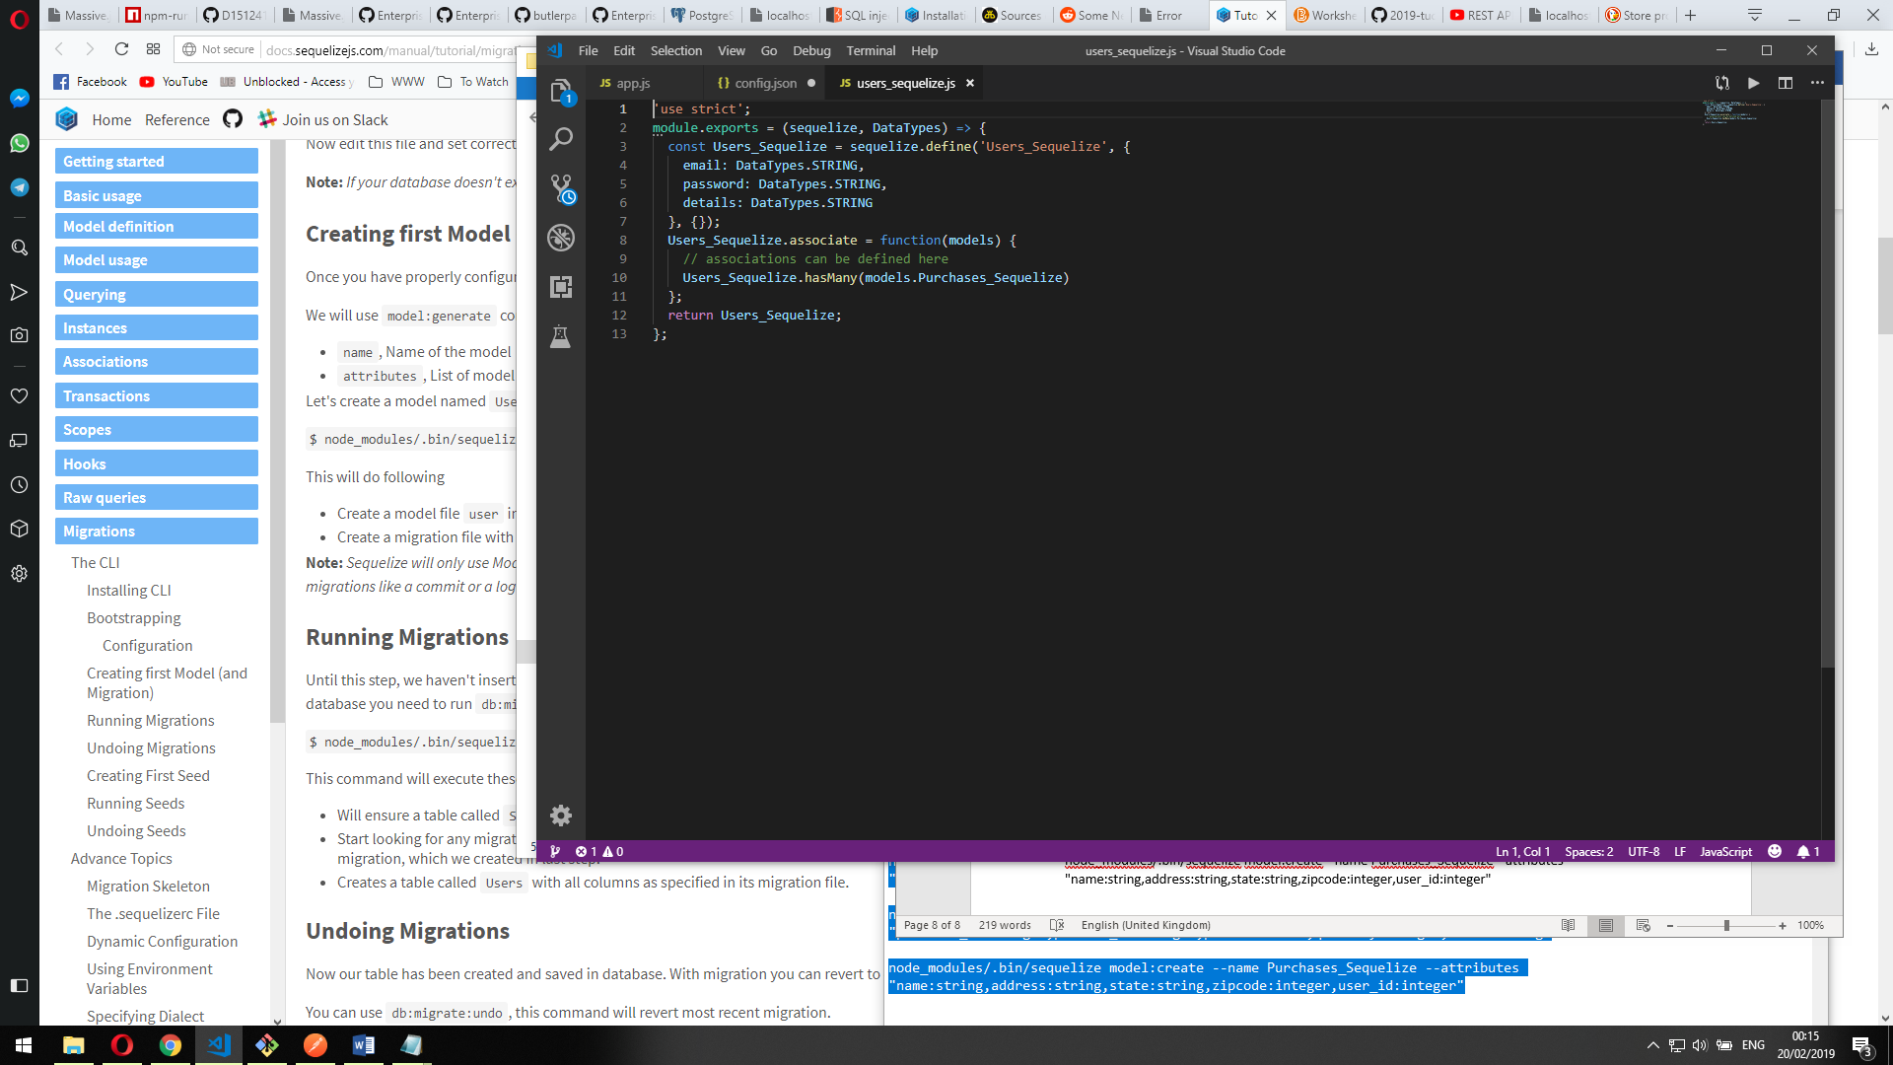

node_modules/.bin/sequelize model:create --name Products_Sequelize --attributes "title:string,price:numeric,tags:string"

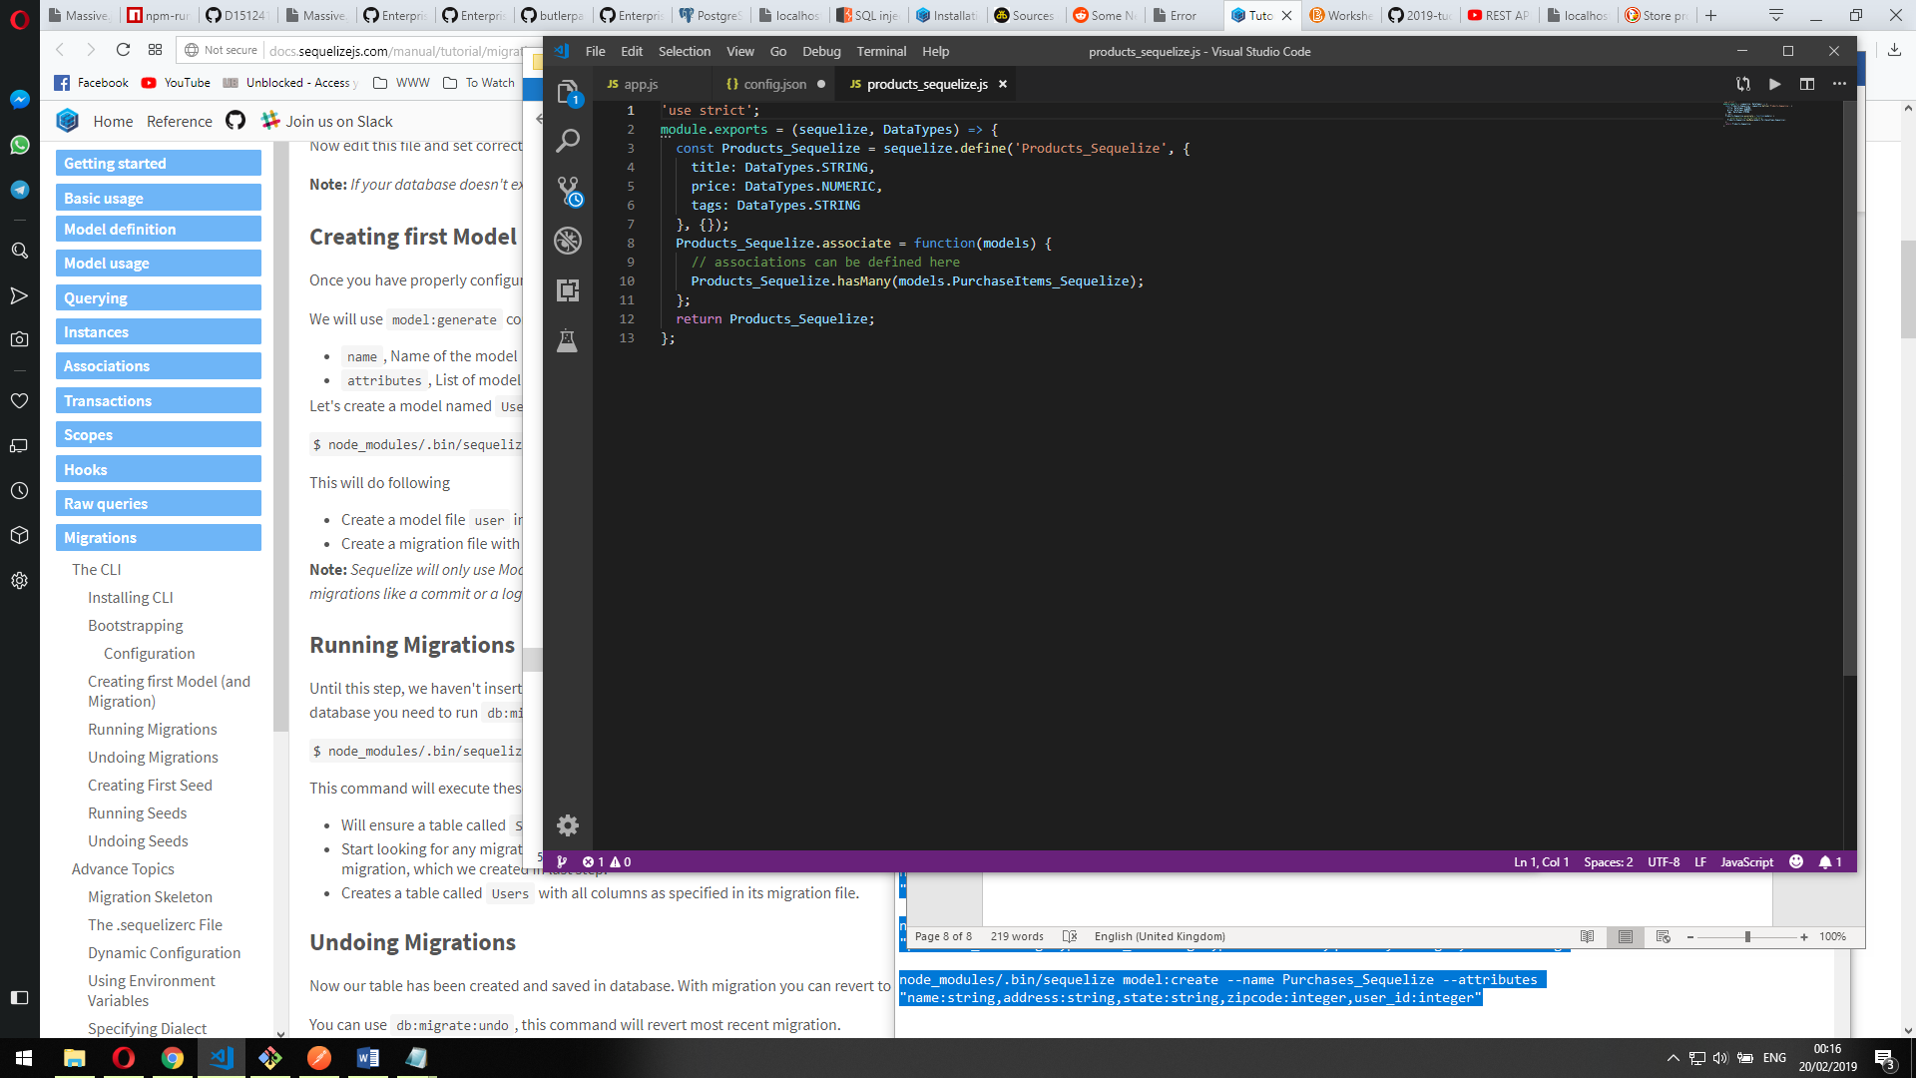

node_modules/.bin/sequelize model:create --name PurchaseItems_Sequelize --attributes "purchase_id:integer,product_id:integer,price:numeric,quantity:integer,state:string"

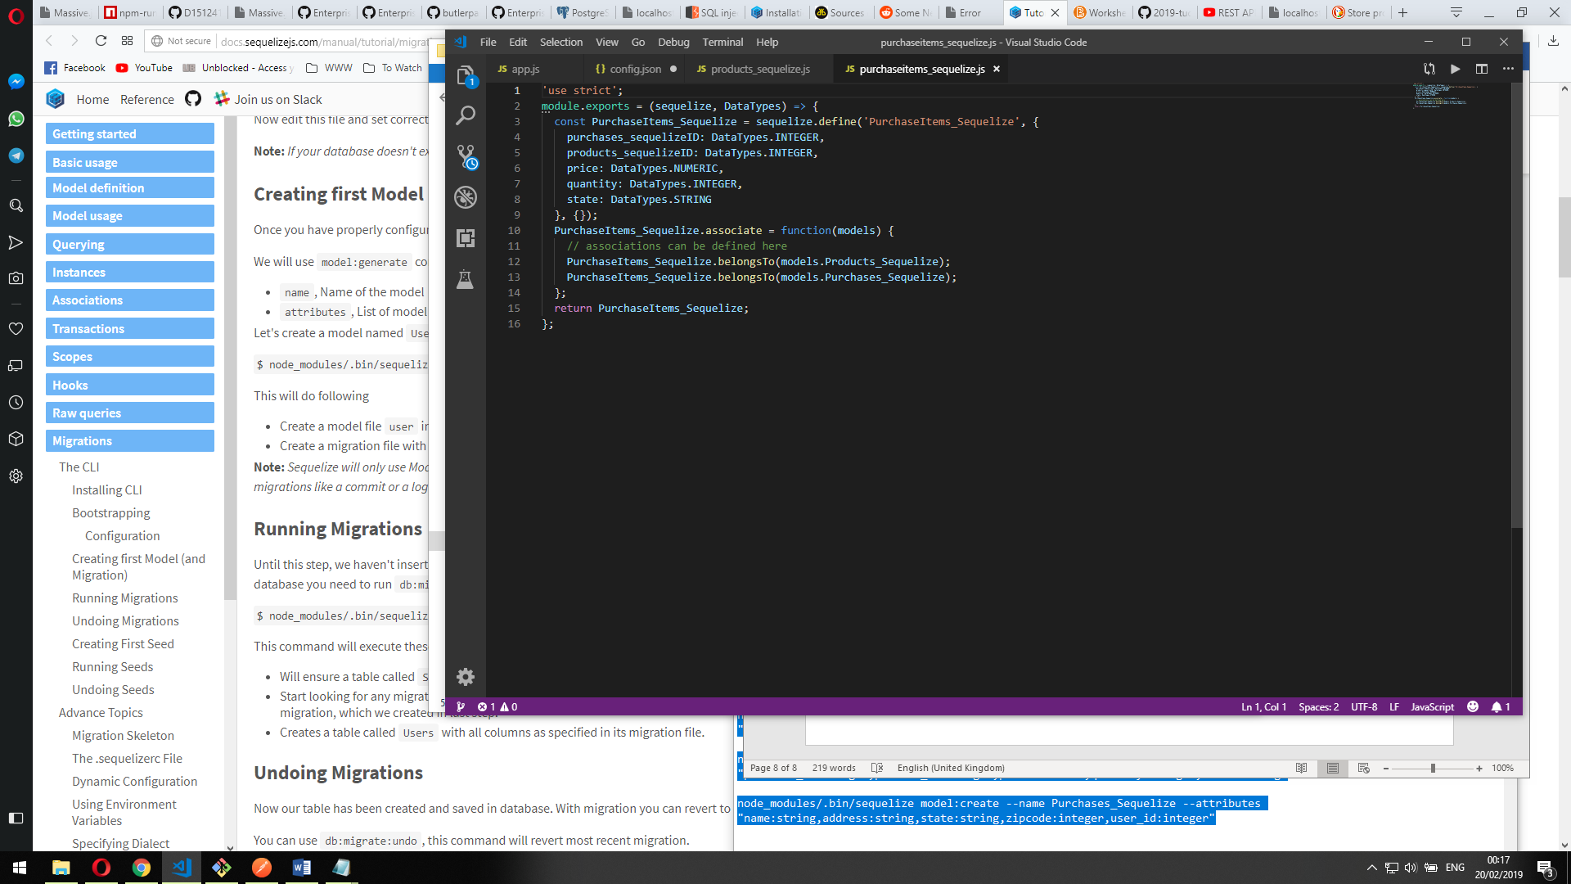

node_modules/.bin/sequelize model:create --name Purchases_Sequelize --attributes "name:string,address:string,state:string,zipcode:integer,user_id:integer"

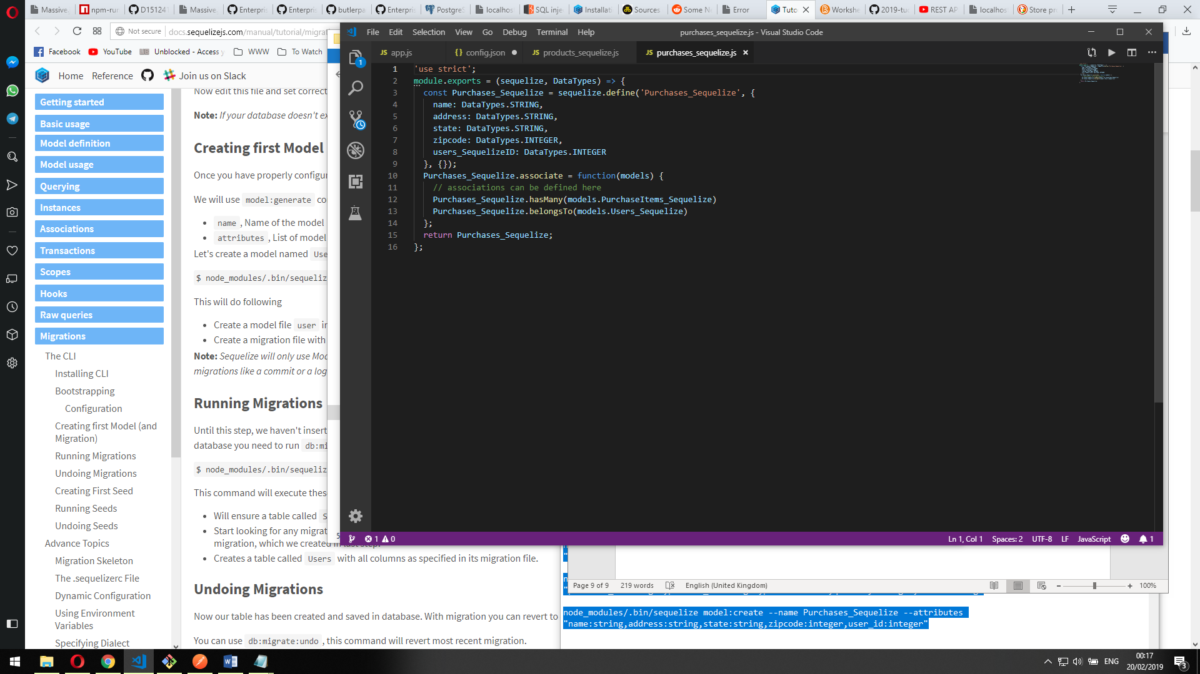

The above commands also generated files in the “migrations” folder that show the table structures of the new tables, defining each field’s type and any additional parameters

Users migration file:

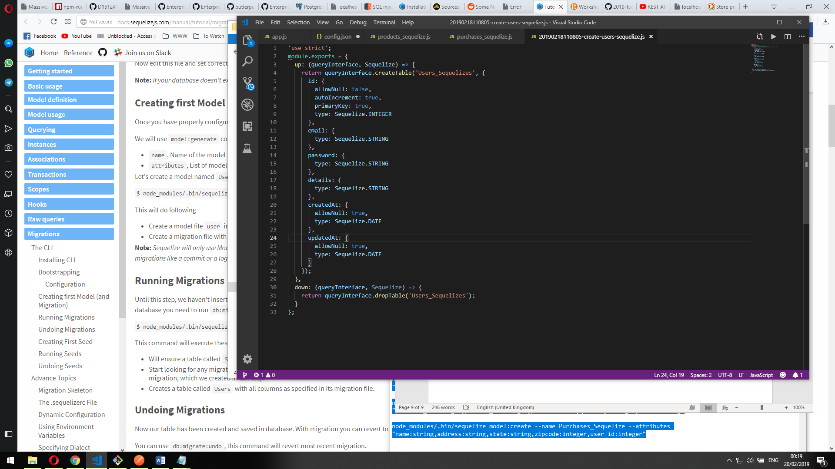

Products migration file:

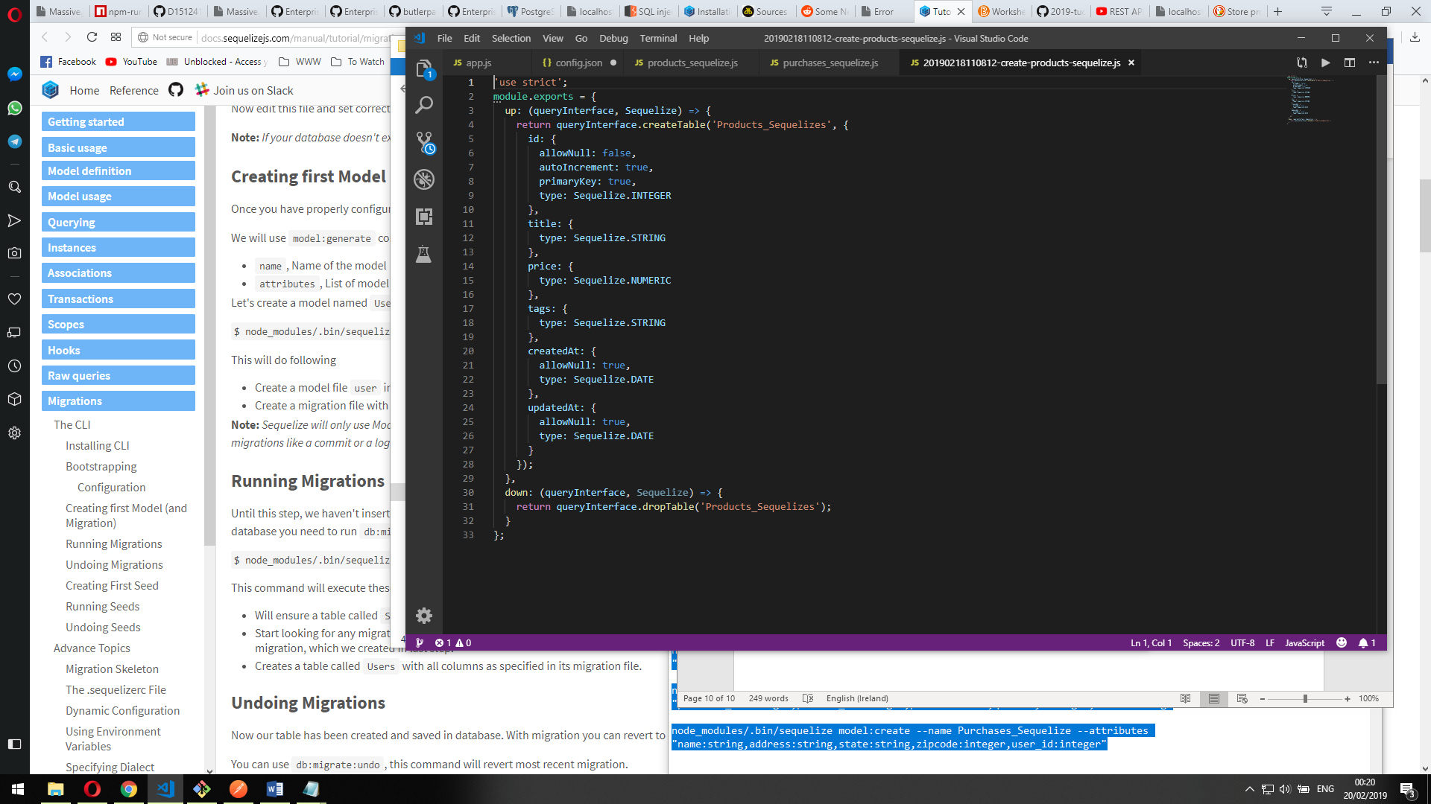

Purchase items migration file:

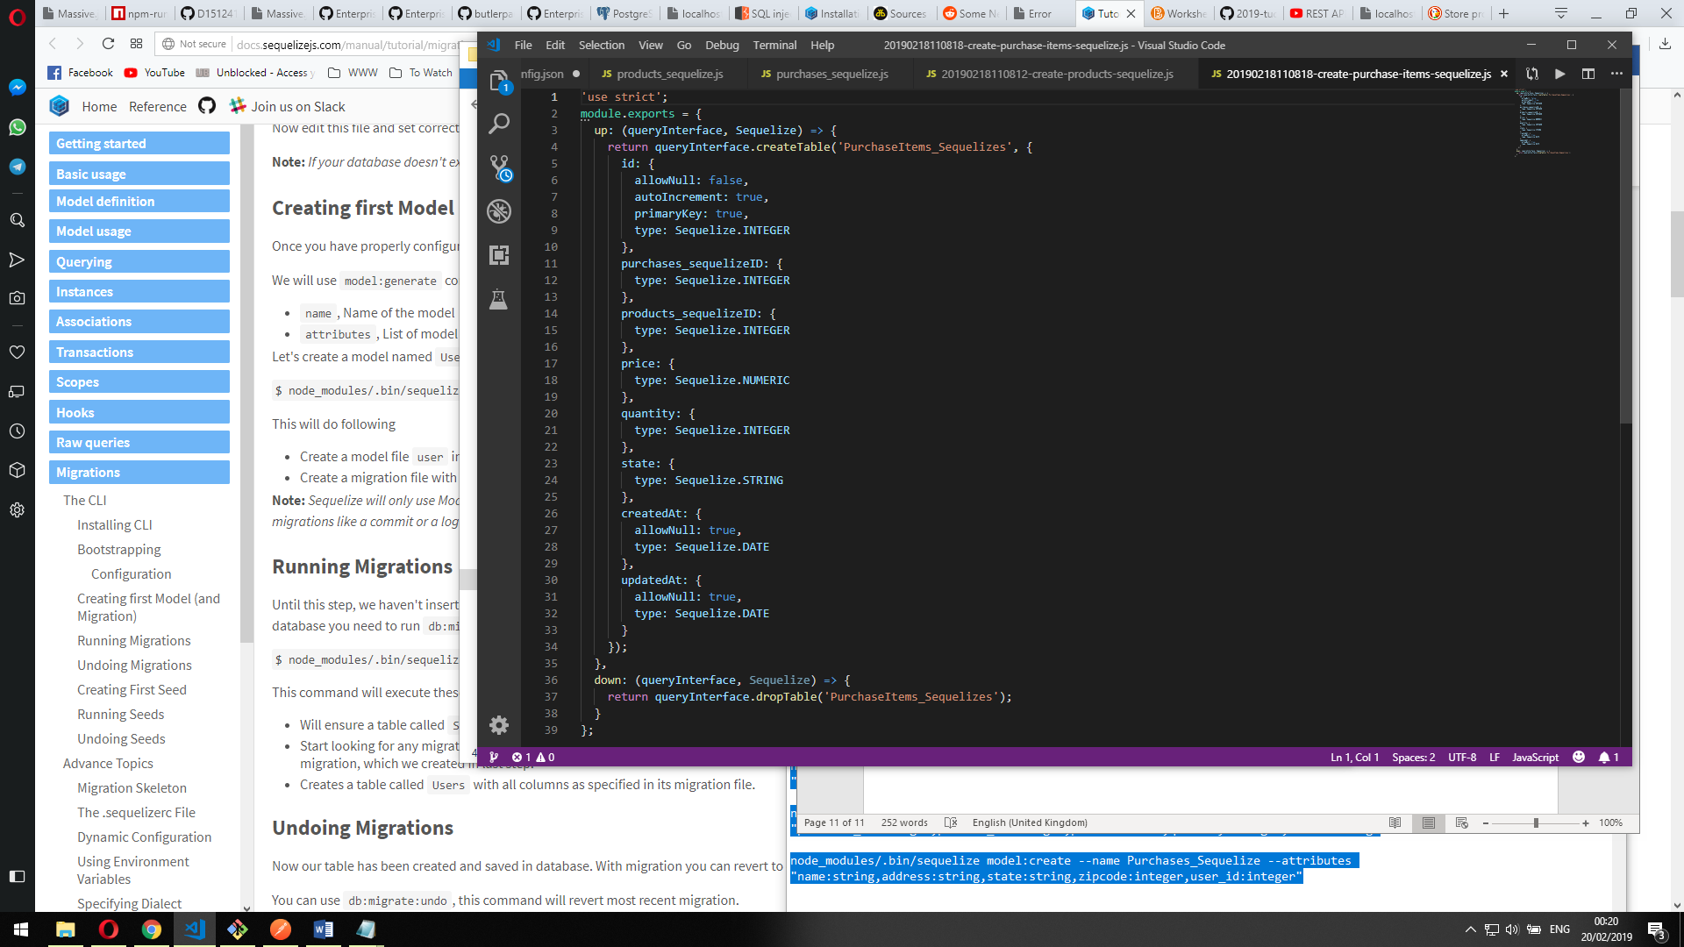

Purchase table migration file:

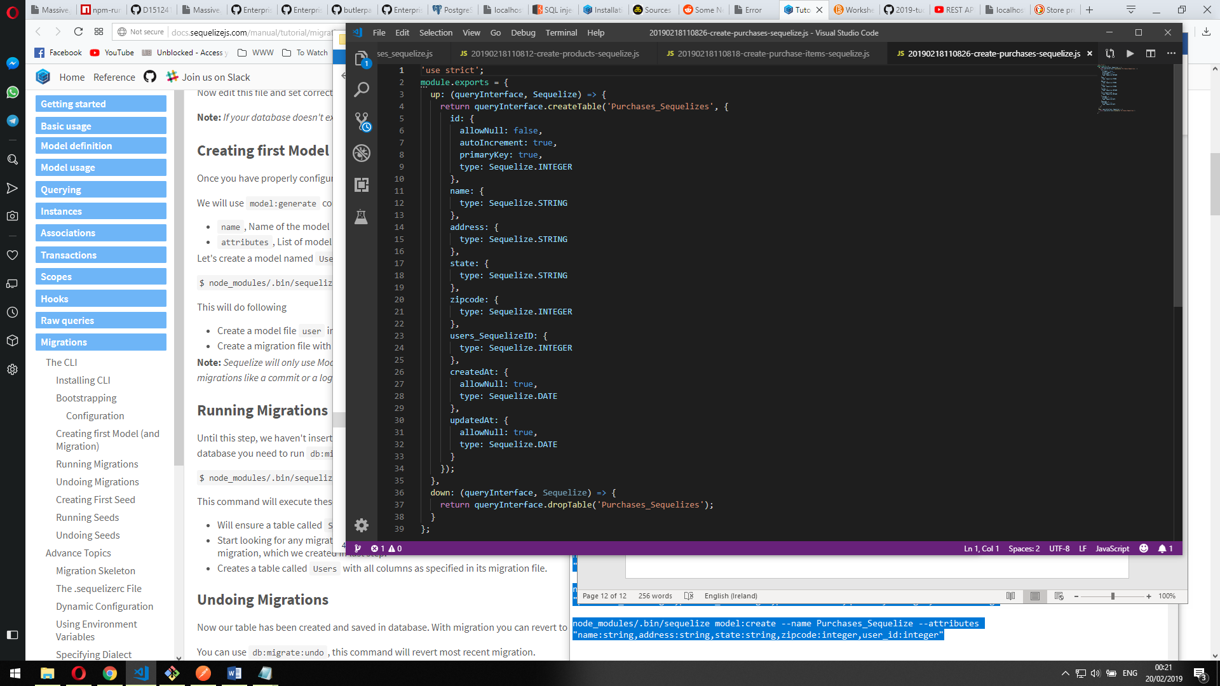

Then I used the

“node_modules/.bin/sequelize db:migrate” command to use the above files to migrate the database tables using sequelize

Through the use of \d command while logged into the db’s user’s connection you can see the migrated tables

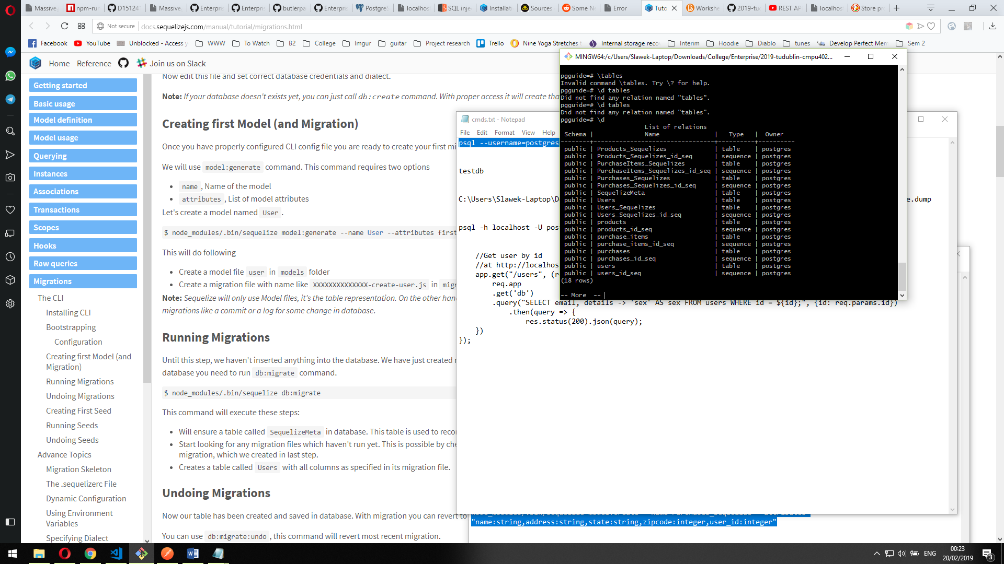

For the next part I generated seeder files with the commands:

node_modules/.bin/sequelize seed:generate --name seedfilename

to generate seeder files which will help me populate new data into the tables

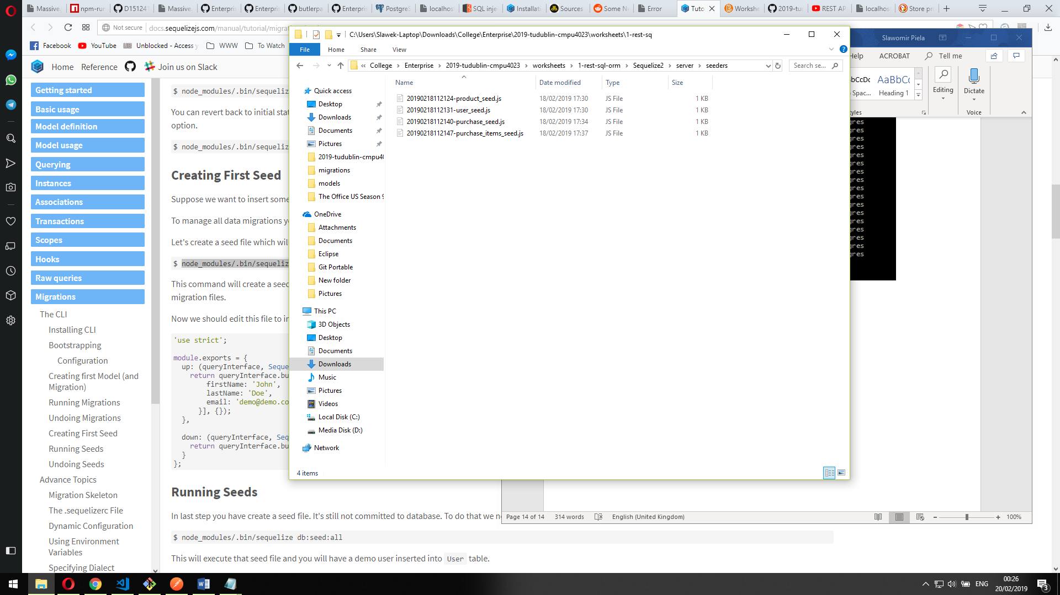

Then I edited the newly generated files in JS to create entries in the database

User-seed file:

'use strict';

module.exports = {

up: (queryInterface, Sequelize) => {

return queryInterface.bulkInsert('Users_Sequelizes', [{

email: 'user1@gmail.com',

password: 'pass',

details: 'testUser',

}], {});

},

down: (queryInterface, Sequelize) => {

return queryInterface.bulkDelete('Users_Sequelizes', null, {});

}

};

Products-seed file

'use strict';

module.exports = {

up: (queryInterface, Sequelize) => {

return queryInterface.bulkInsert('Products_Sequelizes', [{

title: 'Product1',

price: 22.00,

tags: 'testType'

}])

},

down: (queryInterface, Sequelize) => {

return queryInterface.bulkDelete('Products_Sequelizes', null, {});

}

};

Purchases-seed file:

'use strict';

module.exports = {

up: (queryInterface, Sequelize) => {

return queryInterface.bulkInsert('Purchases_Sequelizes', [{

name: 'Slawek',

address: 'Howth, Dublin',

state: 'Leinster',

zipcode: 50020,

users_SequelizeID: 1

}])

},

down: (queryInterface, Sequelize) => {

return queryInterface.bulkDelete('Purchases_Sequelizes', null, {});

}

};

PurchaseItems-seed file

'use strict';

module.exports = {

up: (queryInterface, Sequelize) => {

return queryInterface.bulkInsert('PurchaseItems_Sequelizes', [{

purchases_sequelizeID: 1,

products_sequelizeID: 1,

price: 200.00,

quantity: 5,

state: 'Florida'

}])

},

down: (queryInterface, Sequelize) => {

return queryInterface.bulkDelete('PurchaseItems_Sequelizes', null, {});

}

};

I used the

“node_modules/.bin/sequelize db:seed:all”

command to run all these scripts to create entries in my tables

I installed program called PostMan to allow me to send GET/POST/PUT/DELETE queries to my local server

I reimplemented get requests in code compatible with sequelize and added additional post/put/delete queries

//Get requests - all products

app.get("/products",(req,res)=>{

models.Products_Sequelize.findAll({})

.then(products => {

res.json(products);

});

});

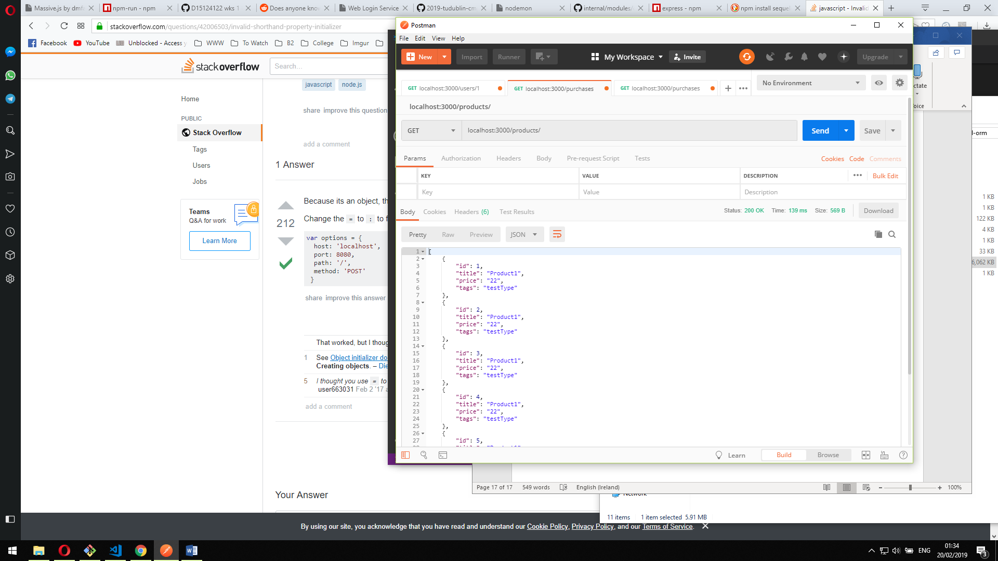

Get a product

//get a product

app.get("/products/:id",(req,res)=>{

models.Products_Sequelize.find({

where:{

id:req.params.id

}

})

.then(product => {

res.json(product);

})

});

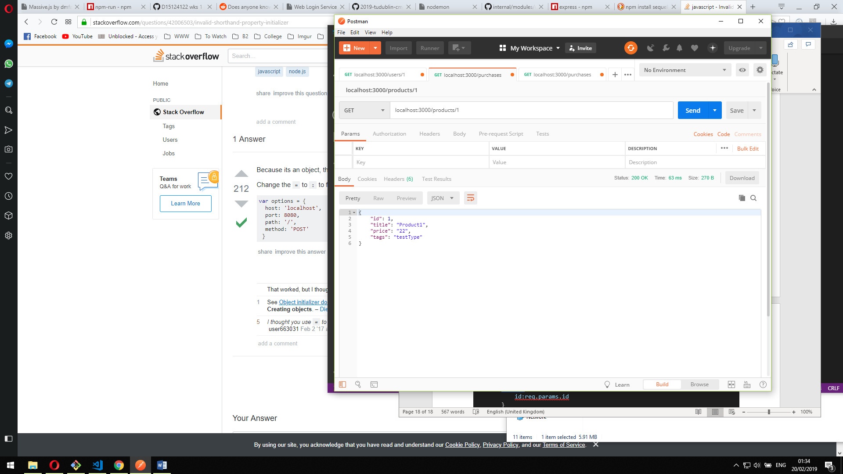

Create a product

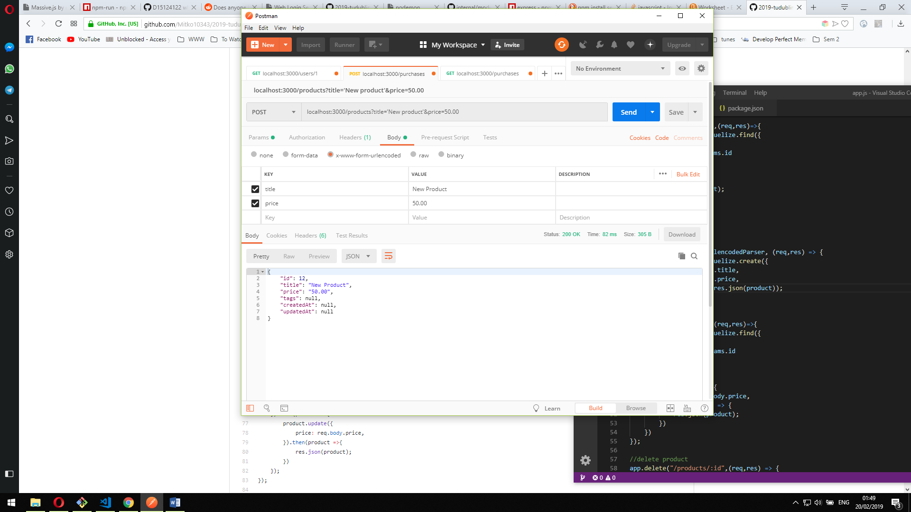

//create product

app.post("/products",urlencodedParser, (req,res) => {

models.Products_Sequelize.create({

title: req.body.title,

price: req.body.price,

}).then(product => res.json(product));

});

Update a product

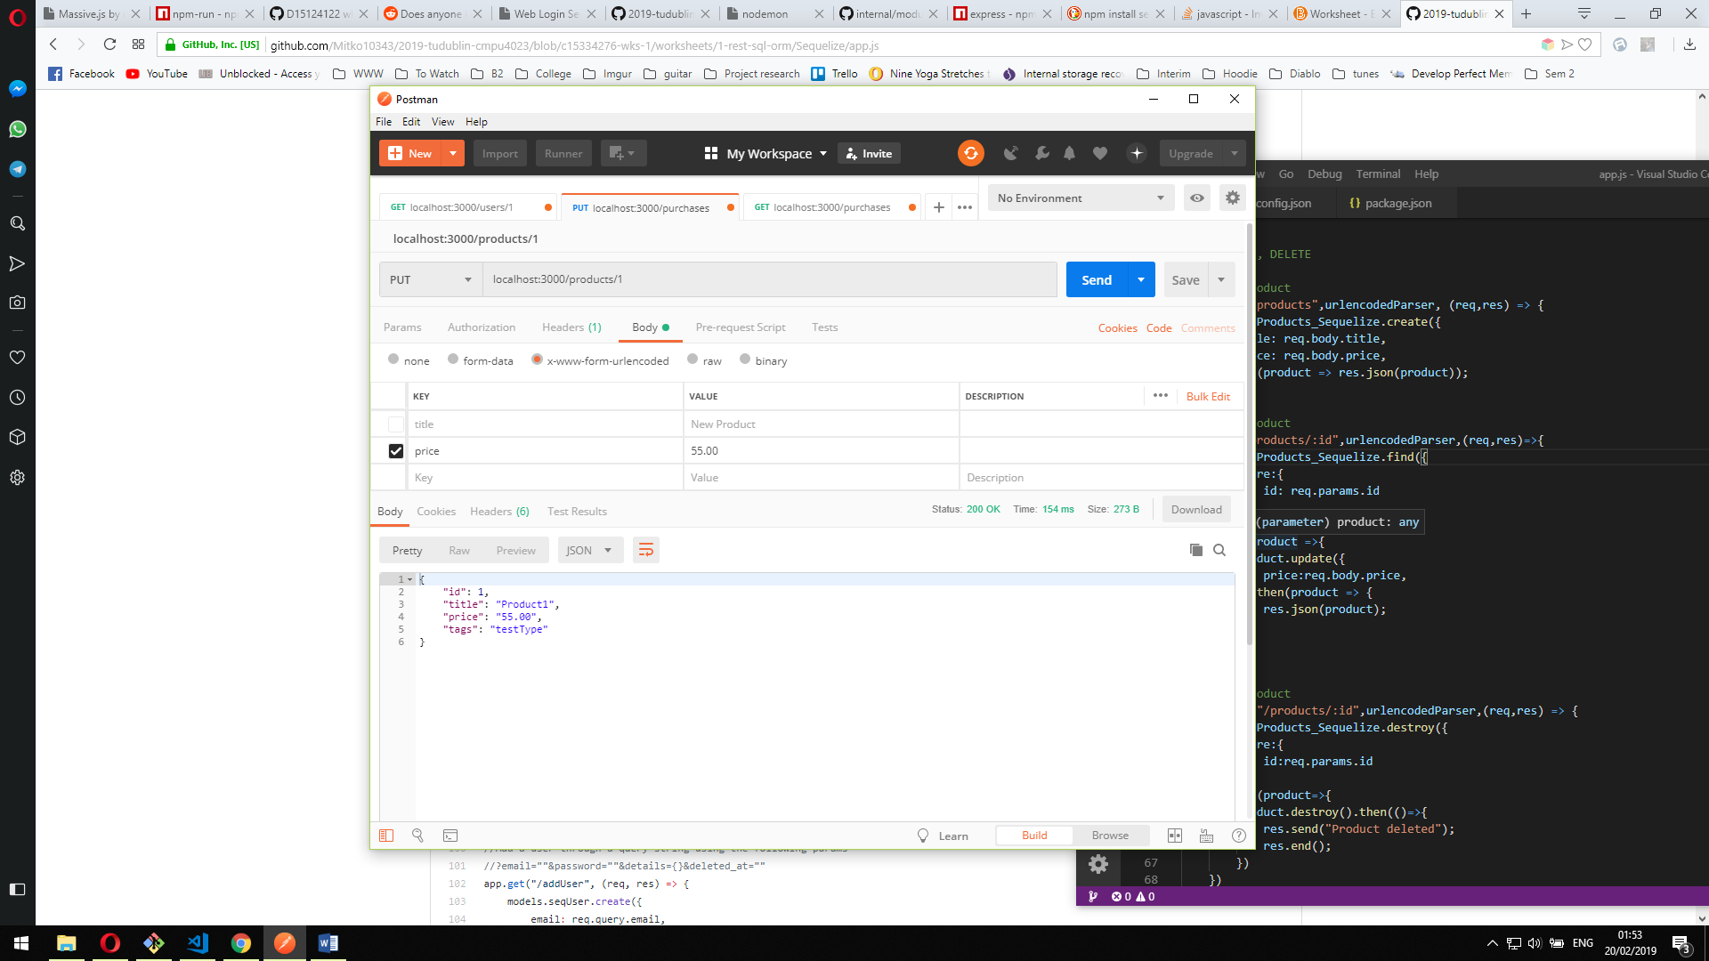

//update product

app.put("/products/:id",urlencodedParser,(req,res)=>{

models.Products_Sequelize.find({

where:{

id: req.params.id

}

})

.then(product =>{

product.update({

price:req.body.price,

}).then(product => {

res.json(product);

})

})

});

Delete a product

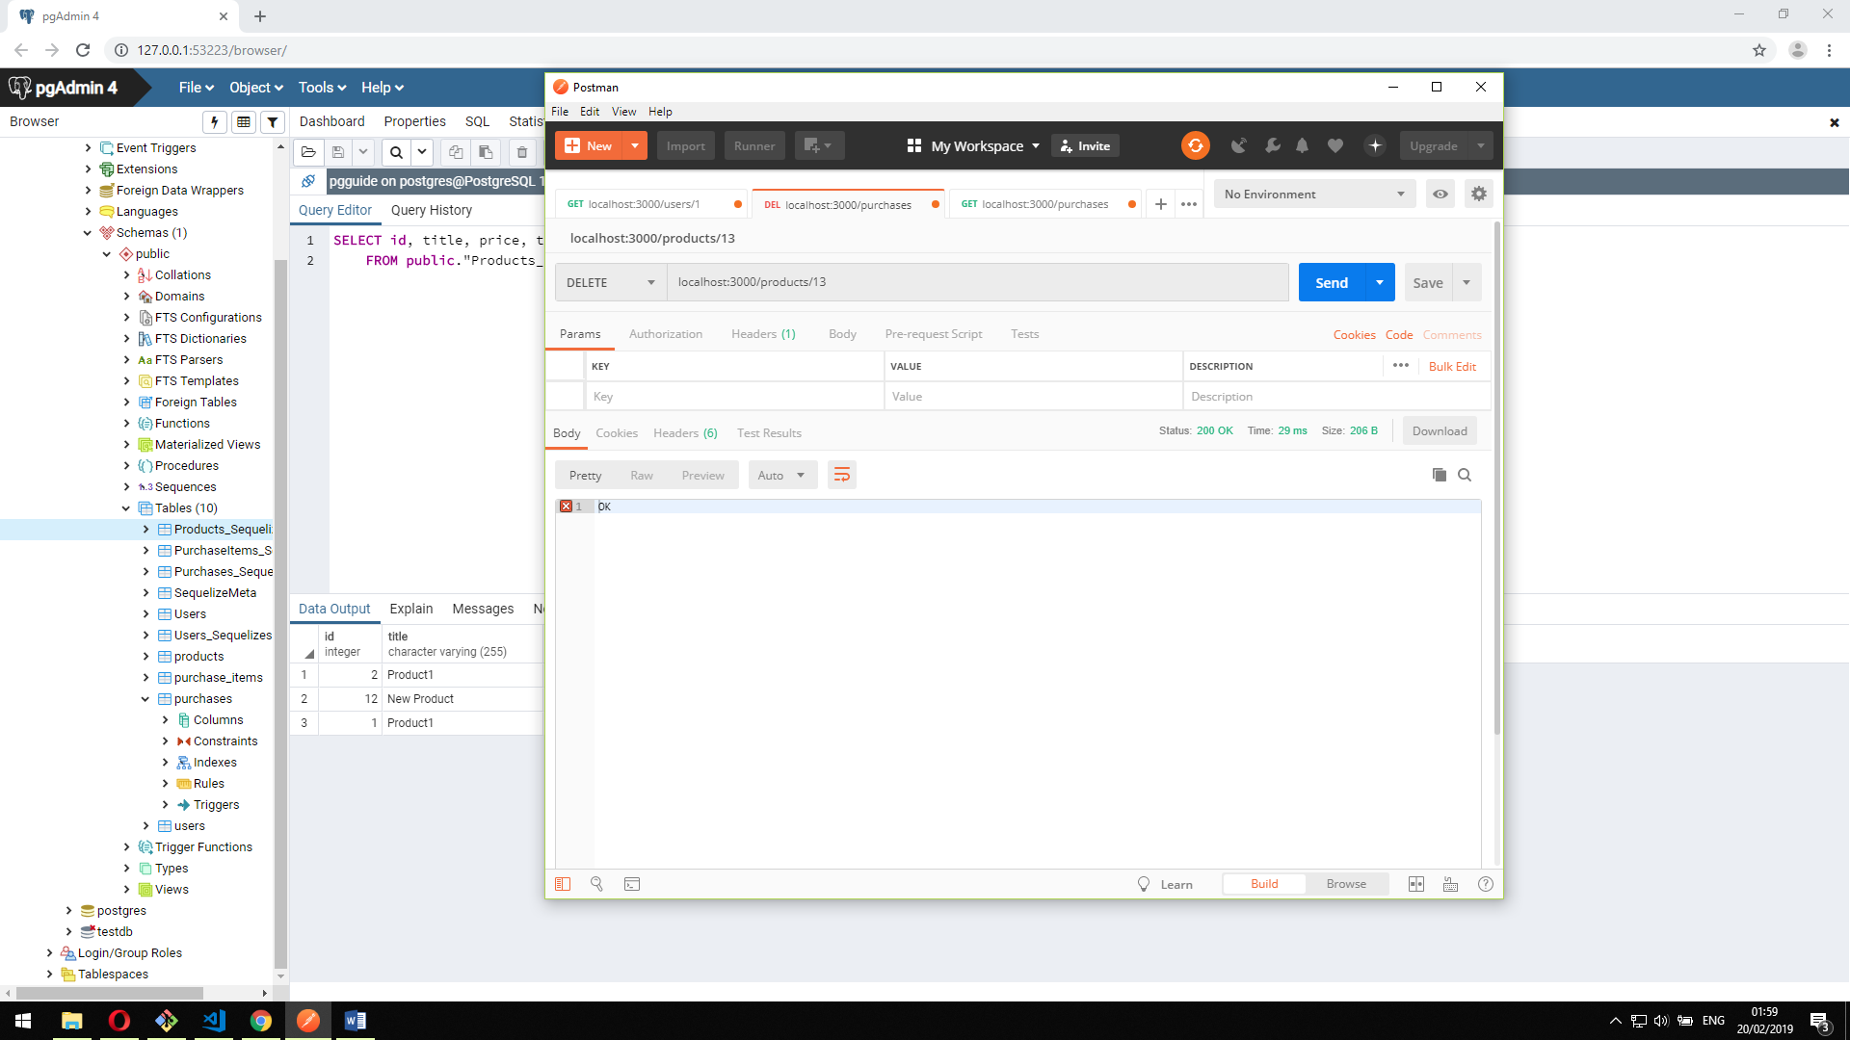

//delete product

app.delete("/products/:id",urlencodedParser,(req,res) => {

models.Products_Sequelize.destroy({

where:{

id:req.params.id

}

}).then(product=>{

product.destroy().then(()=>{

res.send("Product deleted");

res.end();

})

})

})